BEE 495/496 

Capstone Project Final Report

**Project Title: DC-AC Inverter for Photovoltaic System**

Student Name: Justus Bautista

Student Name: Chase Montoure

Student Name: Kenney Louie

Student Name: Justin Mendoza

Advisor: Harry Aintablain

**Table of Contents**

1. Introduction

1.1 Purpose

1.2 Definitions/Acronyms

1.3 Intended Audience

1.4. Background and Motivation

1.5. System Description

2. Specification and Deliverables

3. System Design

3.1. High-level System Diagram and Description

3.2. Detailed Design Description

3.2.1 Flyback converter design

3.2.2 Dc to AC inverter design

3.2.3 Simulation Results

3.3 PCB Layout and Fabrication

4. Test Plan and Results

4.1. Test Plan

4.2. Test Results

4.2.1 Prototype hardware test results

4.2.2 PCB test results

5. Schedule and Milestones

6. Reflections

6.1. Accomplishments

6.2. Learning Experience

6.3. Team Experience

6.4. What Would We Have Done Differently?

6.5. Future Work

7. References

8. Acknowledgements

9. Appendices

9.1 Flyback converter Bill of Materials

9.2 Dc to AC inverter Bill of Materials

## 1. Introduction

A photovoltaic system (PV) is a way of harnessing solar energy and converting it into electricity. A PV consists of a solar panel, a power converter, and a connection to some system such as a home or a battery for storage. The purpose of this capstone project is to design and build a DC-AC inverter for use in a PV home system. A DC-AC Inverter converts DC power to AC power which is utilized in the power system. The system Inverter will be designed at full scale (120Vrms at 60Hz) and then a small scale model will be built and tested to validate that the design works.

##### 1.1 Purpose

This document outlines the project plan and background information regarding the DC-AC Inverter for a photovoltaic system. Including the goals, theory, design, tentative schedule, implementation plan, and deliverables for this capstone projects.

##### 1.2 Definitions/Acronyms

A - Ampere

AC - Alternating Current

DC - Direct Current

F - Frequency

GND - Ground

I/O - Input/Output

IC - Integrated Circuit

MA - Amplitude Modulation

MF - Frequency Modulation

MOSFET - Metal-Oxide Semiconductor Field-Effect Transistor

PCB - Printed Circuit Board

PWM - Pulse Width Modulation

V - Voltage

VDS - Voltage Drain to Source

VRMS - Root Mean Square Voltage

W - Watt

##### 1.3 Intended Audience

The target audience intended for this document is for our industrial and academic advisors, as well as the UW Bothell EE department for evaluation purposes. In addition, We also aim to inform future, former, and present capstone students in order to help them prepare and understand the documentation process of a project.

##### 1.4. Background and Motivation

The purpose of this project is to implement a small scale model of a DC-AC inverter for use in a photovoltaic system. This model serves as proof of concept that our design works and can be upscaled for commercial use.

Photovoltaic System

A photovoltaic system is a system that transforms solar energy into electrical energy. In most applications it consists of a solar panel that delivers DC power to a DC-AC inverter (see figure 1.1). This power is then delivered to the grid or directly to a home by connecting the system to a home’s main fuse box and/or to the utility meter and power grid. If the system is tied to the grid it is required to have grounding isolation to protect against faults. If a fault is detected the system detaches from the grid in order to prevent damage to the system.

In this project, we will focus on an isolated system rather than one ties to the grid. This system is isolated, and includes a solar panel that charges a battery and the voltage from the battery is inverted to AC to power the home.

**Figure 1.1 High Level Block Diagram of PV System**

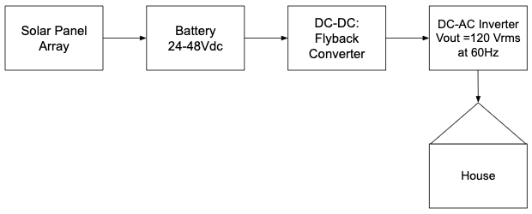

DC-AC Inverter

Two types of inverter configurations are commonly used in a PV system one with a transformer and one without. In both cases, two stages are used to transform the power into a form usable in home (V = 120 Vrms f = 60Hz). The first stage is a DC-DC converter that steps up the voltage from the battery (24-48V typically) to supply a constant output voltage. The DC-AC Inverter then converts the DC source into an AC sinusoidal voltage at a maximum power rating of 500W.

In a system with a transformer, the isolation is established in the DC-DC converter using a flyback or boost configuration. The transformer separates the grounds of the battery and solar panel from the rest of the system (see figure 1.1). A major disadvantage of this topology is the large size and weight of the transformer. The isolation can help reduce noise and prevent current injection due to ground mismatch.

In a system without a transformer, no isolation is established. This configuration has the advantage of being lighter and smaller. However the lack of isolation is undesirable for high power applications where power is transferred over long distances.

Because our project is focused on providing a solution for households, safety is a major concern. Therefore, we decided to use an isolated configuration for our inverter.

Pulse Width Modulation (PWM)

PWM is a control system technique used to regulate the power delivered to a system. It is done by generating a square wave signal at some *duty cycle* which is defined as the ratio that the square wave is on over the period of the signal. This signal is fed to a MOSFET switch which turns on and off based on the PWM signal. One way of creating a PWM control is by generating a triangle and sine wave and feeding this into a comparator. When the sine wave amplitude is greater than the triangle wave the comparator will output a “high” signal and generate a “low” output otherwise. Thus turning the MOSFET on and off respectively (see figure 1.2 below).

Figure 1.2 PWM Basic Control Scheme

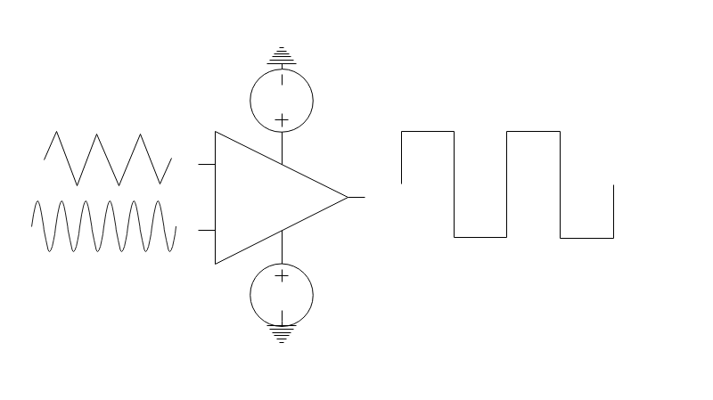

Amplitude Modulation

Amplitude Modulation (ma) is the ratio of the sine wave vs the triangle wave. The amplitude of the fundamental frequency (V1, amplitude at f=60Hz) is controlled by this ratio if the ratio is at or below 1 (V1 = ma*Vdc). At higher ratios this linear relationship does not hold and other techniques must be used to find the amplitude V1.

Frequency Modulation

Frequency Modulation (mf) is defined as the ratio of the triangle wave vs the sine wave. Increasing the triangle wave frequency increases the harmonics or frequencies at which amplitudes can be seen (V2, V3, Vn) increase. In general a mf > 15 is desired to make it easier to filter out unwanted signals.

##### 1.5. System Description

Our System consists of three major components, the DC-DC step up converter, the DC-AC inverter and the PWM control circuit. The DC-DC step up circuit is a flyback converter that uses a power MOSFET and a control signal to regulate the output voltage at the desired output. The MOSFET control signal is supplied to a transformer that is then fed to the output. A flyback converter provides isolation for the inverter from the power source which complies with safety concerns that are present in a PV system.

**Figure 1.3 Flyback Configuration**

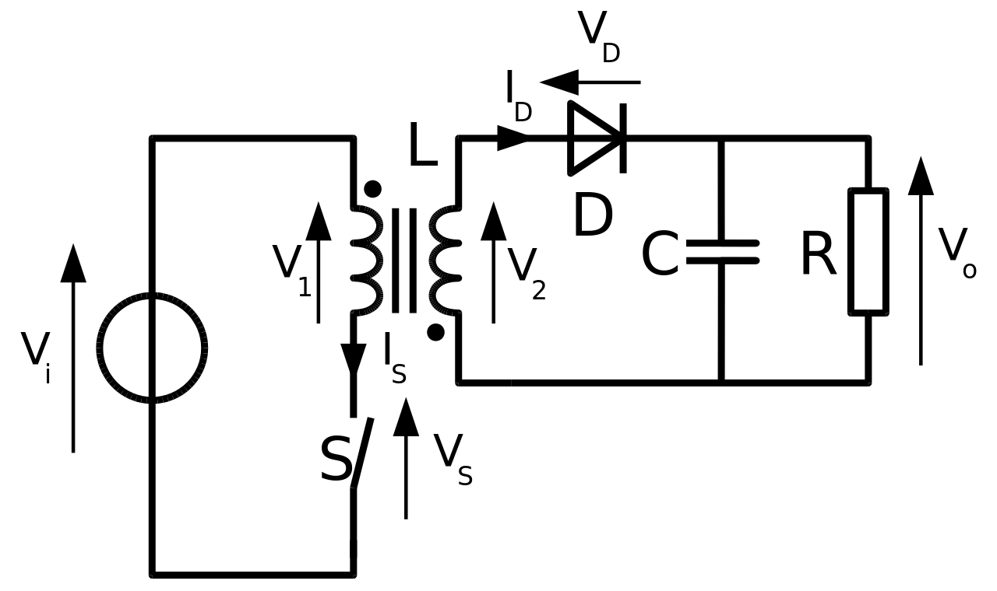

* *Cyril BUTTAY Wikipedia*

The DC-AC inverter circuit utilizes a full-bridge configuration with a bipolar switching scheme. This was chosen because it is relatively simple to implement and provides the precision necessary to generate a sinusoidal wave from. The circuit works by controlling 4 MOSFETs all connected to a load, these FETs are controlled by PWM.

**Figure 1.4 Full-Bridge (H-Bridge) Configuration**

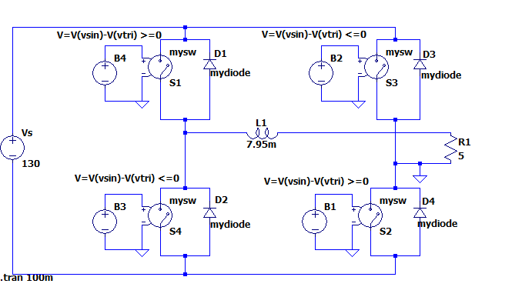

In the figure shown above the MOSFETS are replaced with switches in order to better understand how the circuit operates. When switch 1 and 2 are on the output voltage positive Vs, when switch 3 and 4 are on the output voltage is negative Vs. The output voltage is passed through a low pass filter which results in a sinusoidal output.

**Figure 1.5 Unfiltered Output**

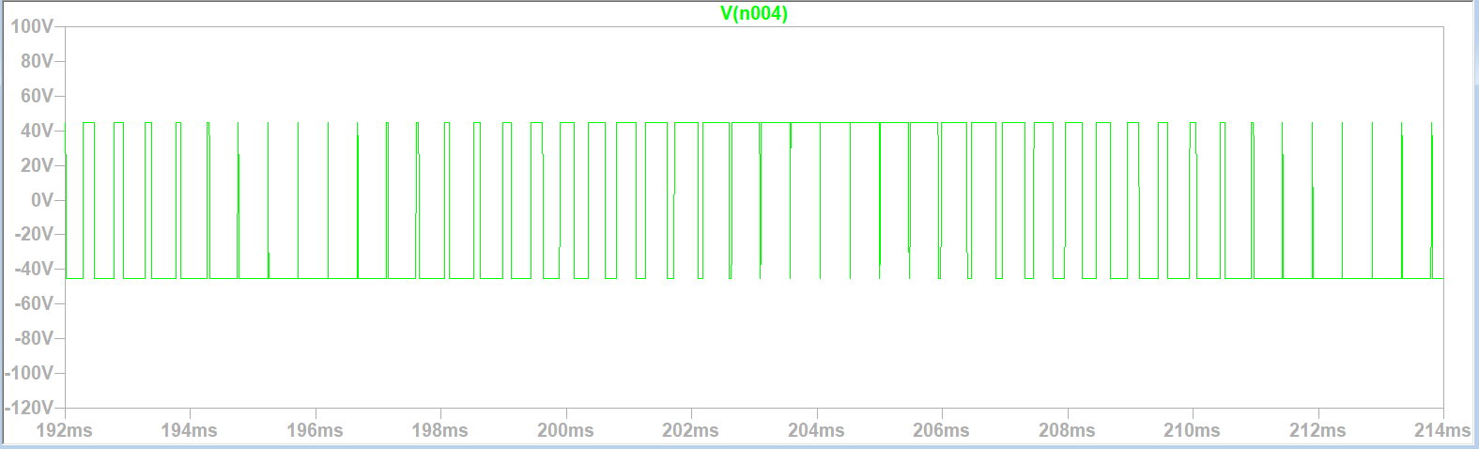

**Comment:** Input voltage in this simulation is different from Vs shown in figure 1.5.2

**Figure 1.6 Filtered Output**

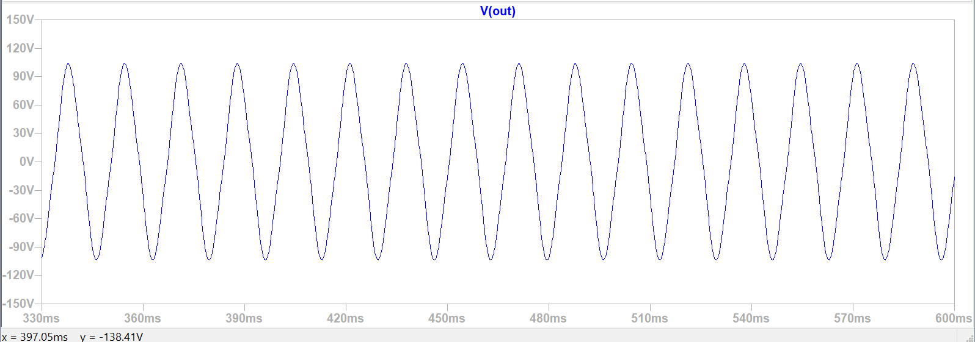

The final circuit in our system design is the PWM circuit, this circuit generates a signal that controls the full-bridge in our DC-AC inverter. This system operates using several opamps to generate a low power sine and triangle wave that are then fed into two different comparator circuits.

## 2. Specification and Deliverables

## 

## 3. System Design

##### 3.1. High-level System Diagram and Description



The system consists of a DC-DC Flyback converter, DC-AC Inverter, and PWM control unit. The Flyback converter regulates input DC voltage for the Inverter. The PWM controls the mosfets in the Inverter as switches. The Inverter produces an output sine wave at a frequency of 60 Hz.

##### 3.2. Detailed Design Description

##### 3.2.1 Flyback converter design

Flyback Driver

The LT3748 is a switching regulation controller that was designed with an isolated flyback converter for application. This drives an internal supply voltage of 7 V into an external mosfet that will be used as a switch for the Flyback converter. The Vin pin takes input voltage to power the internal circuitry of the IC. The Vc pin of the IC is for voltage compensation of the switch regulator and to eliminate noise. The SS (Soft Start) pin is to delay the start up by clamping the Vc pin voltage. Switching doesn’t begin until the SS pin reaches ~0.65 V. The INTVcc pin supplies the current for the internal gate driver for the LT3748. The Gate pin is the mosfet gate driver that switches between INTVcc and GND. The EN/UVLO pin is used for undervoltage lockout. When the pin is below 1.223 V, the internal circuitry will not turn on. When above 1.223V, the internal circuitry will turn on and function.

Using the IC, a gate voltage is driven into the gate of the mosfet with a switching frequency determined by the current sense resistor. This would enable the charging and discharging of the internal inductance at the input transformer and of the external capacitor at the output of the transformer.

With the values of the transformer and load being static, three values that we can change to influence the output is the reference and feedback resistors, as well as the current sense resistor. In the case of the reference and feedback resistors, LT3748 takes the ratio of these resistances and changes and adjustments based on the chosen values. For the current sense resistor, the switching frequency can be changed with different values and as a result, affect the charging/discharging rates of the transformer thus changing Vout.

**Figure 3.1 LT3748 IC Layout**

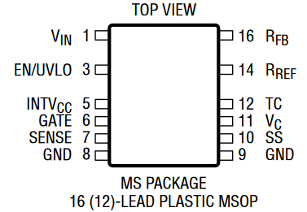

**Table 3.1 Pin Description**

|  |  |  |
| --- | --- | --- |
| **Number** | **Name** | **Functional Description** |
| 1 | VIN | Input Voltage |
| 3 | EN/UVLO | Enable/Undervoltage Lockout |
| 5 | INTVCC | Gate Driver Bias Voltage |
| 6 | GATE | N-MOS Gate Driver Output |
| 7 | SENSE | Current Sense Input for the Control Loop. |
| 8 | GRD | Ground |
| 9 | GRD | Ground |
| 10 | SS | Soft Start Pin |
| 11 | VC | Compensation Pin for the Internal Error Amplifier |
| 12 | TC | Output Voltage Temperature Compensation |
| 14 | RREF | Input Pin for the External Ground-Referred Reference Resistor |
| 16 | RFB | Input Pin for the External Feedback Resistor |

**Table 3.2 IR2304 Electrical Characteristics**

|  |  |  |
| --- | --- | --- |
| **Characteristic** | **Rating** | **Unit** |
| VIN | 5-100 | V |
| INTVCC | 4.5-20 | V |
| Min GATE Off-Time | 700 | ns |
| Min GATE On-Time | 250 | ns |
| Max GATE Off-Time | 55 | μs |
| Max GATE On-Time | 55 | μs |

##### 3.2.2 DC-AC inverter design

*PWM Control Unit*

The PWM Control Unit generates the control signals used to turn the MOSFETs on and off. A sine triangle wave circuit are input into two comparators to generate a PWM.

The sine wave generator is a practical Wien-bridge oscillator with amplitude control.The sine wave has a set frequency of f =1/(2*pi*R*C). The potentiometer in the sine wave is used for amplitude modulation where gain = potentiometer / 10kΩ. A ~20 Hz high pass filter is used to filter out the DC offset at the output of the sine wave circuit.

The triangle wave circuit consists of two op amp stages. The first stage is an Astable Multi-Vibrator which generates a square wave of a set period T = 2RCln((1 + Beta) / (1 - Beta)), where Beta is R2 / ( R1 + R2 ). R1 and R2 are the voltage divider between the output and the non-inverting input to ground. The second stage is an integrator op amp with DC-Gain control (R in parallel with the capacitor) which helps limit the DC offset at the output. A ~500 Hz high pass filter is used to filter out the DC offset at the output of the triangle wave circuit.

Each comparator chip is designed to have different pulses, one that is low-high and one that is high-low. The comparator outputs would then be input into the mosfet driver.

**Figure 3.2 PWM Circuit Design**

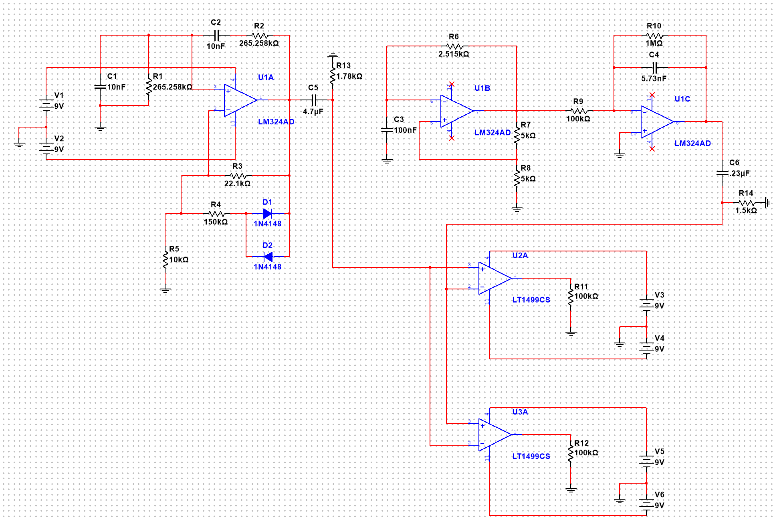

* OP AMPS in circuit model are not the same ones used for prototyping and PCB design. The OP AMPS we used did not have a model available in Multisim.

*MOSET Driver*

The IR2304 is an integrated circuit designed for use in a half-bridge configuration. This IC serves the purpose of boosting the control signal supplied by the PWM circuit to turn on the MOSFETS thus preventing power loss due to the FETs partially turning on. This IC also features a mechanism to prevent *shoot-through* in the circuit i.e it prevents switch 1-4 and 2-3 from being on at the same time. This is important because if both switches are on then the voltage will drop straight to the ground and potentially cause damage to the circuit. This IC was chosen because of its ease of use and high power rating (600V).

**Figure 3.3 IC layout**

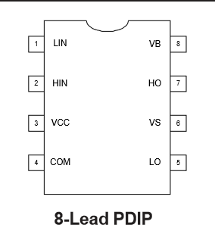

**Table 3.3 Pin Description**

|  |  |  |
| --- | --- | --- |
| **Number** | **Name** | **Functional Description** |
| 1 | LIN | Low MOSFET input signal (PWM) |
| 2 | HIN | High MOSFET input signal |
| 3 | VCC | IC power supply (10-20V) |
| 4 | COM | IC Ground, attaches to VCC and common ground of the entire circuit. |
| 5 | VB | Boost Voltage pin, attaches to Bootstrap capacitor to charge up VCC used to amplify LIN signal. |
| 6 | HO | High MOSFET output signal to gate |
| 7 | VS | Senses voltage at source of top MOSFET and which is used to determine if the top MOSFET should turn on. Note: Low FET driver will operate without Hi side driver but HI side cannot turn on until it detects a voltage drop across the load. |
| 8 | LO | Low MOSFET output signal to gate |

**Table 3.4**

|  |  |  |
| --- | --- | --- |
| **Characteristic** | **Rating** | **Unit** |
| Voffset | 600 | V |
| IO+/- | 60-130 | mA |
| Vout | 10-20 | V |
| Delay Matching | 50 | ns |
| Internal Deadtime | 100 | ns |
| ton/toff | 220/220 | ns |

##### 

In order to control the full-bridge DC-AC inverter two MOSFET drivers are required as shown below.

**Figure 3.4 IR2304 Full Bridge Circuit**



*Pinout*

VCC: Both IC’s are connected to a 10V source at VCC, a decoupling capacitor is attached between VCC and COM.

Lin/Hin: The PWM waveforms generated by the comparator circuits is attached to Lin and Hin, note that IC1 and IC2 have inverted logic i.e Hin and Lin of IC1 and 2 respectively, are tied to PWM 2 and vice versa.

VS: This Pin must be tied to the source if the top MOSFETs (1 and 3) and is tied to a bootstrap capacitor, VB, and pin VCC. When HIN is off or “low” the bootstrap capacitor charges up to VCC and discharges into VB when it is time to turn on HIN again. The diode prevents current from flowing the wrong direction.

Vin: Voltage input from Flyback Converter, note the 100uF decoupling capacitor which was added based on the IR2304 datasheet.

Both sides of the Half Bridge are connected to a low pass filter which filters the square waveform to generate a sine wave output at 60Hz. Note that everything is tied to the same ground.

*Low Pass Filter Design*

In order to get a sinusoidal output, we needed to cut off the unwanted higher harmonics in the output signal. We accomplished this with a second order LC lowpass filter consisting of a 4.7mH inductor, a 30uF capacitor, and a 39 Ohm resistor at the load. Using the equation, $fc=\frac{1}{2π\sqrt{LC}}$

we obtained a cutoff frequency of 424 Hz.

##### 3.2.3 Simulation Results

**Figure 3.5 DC-DC Converter Circuit configuration**

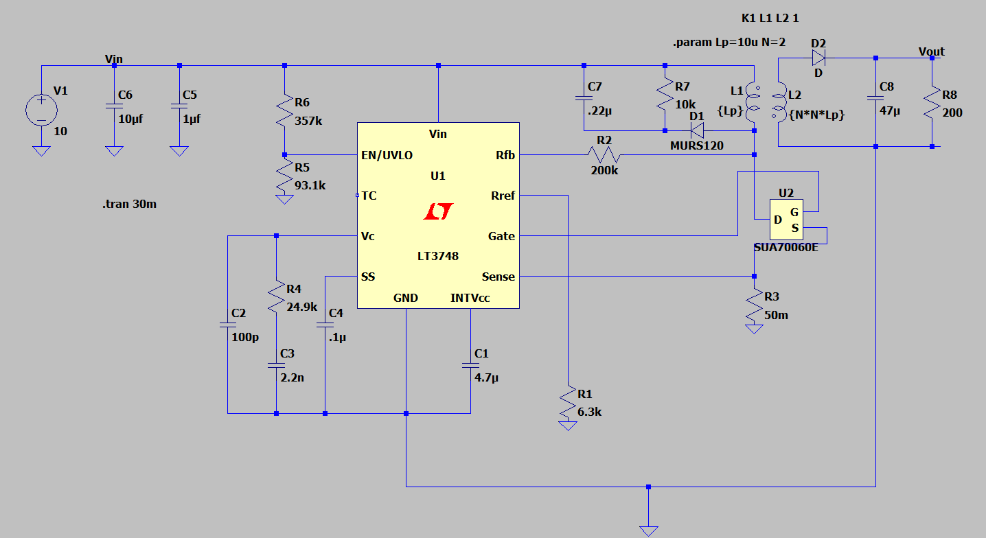

**Comment:** In practice, both sides of the transformer would have isolated grounds, but for simulation purposes, the circuit shares a common ground for quicker computing time.

**Figure 3.6 DC-DC Converter Simulation Output**

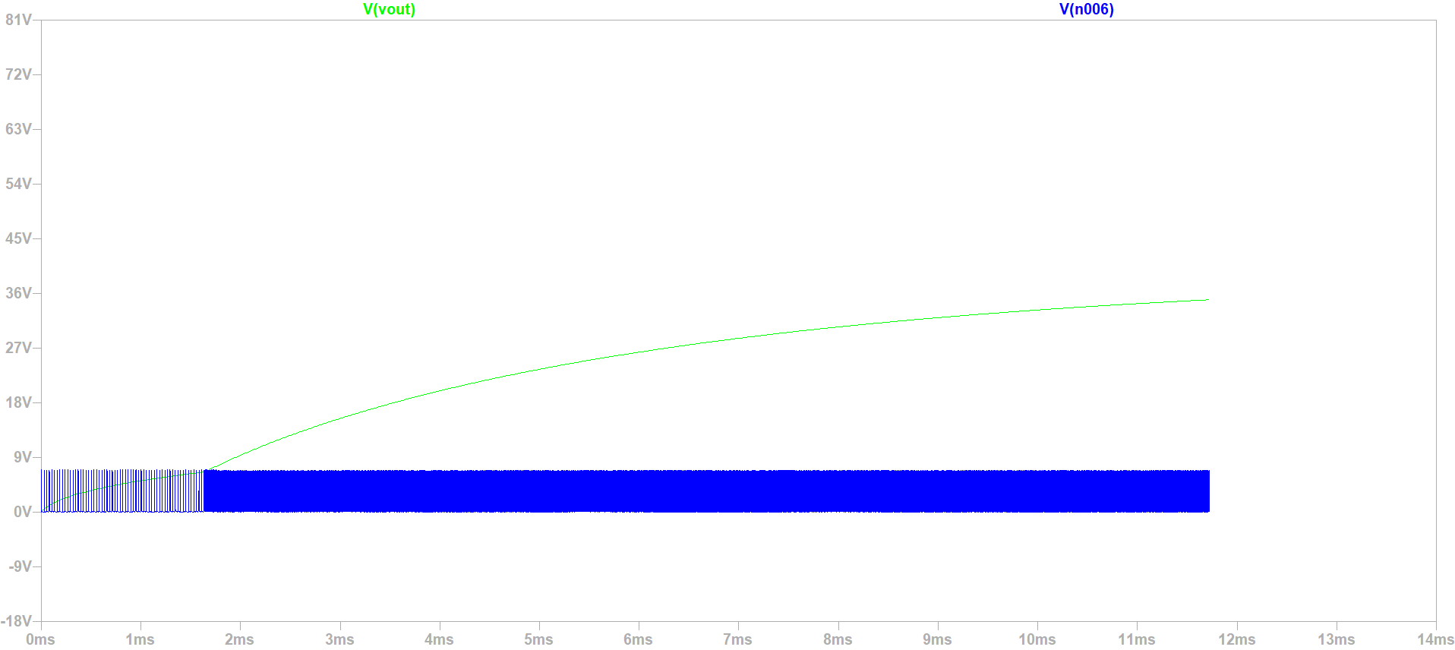

**Comment:** Figure X.X.X shows the Vout of the converter with 20V as Vin. V(n006) represents the pulse signal that is driving the gate of our switching MOSFET. V(n006) is pulsing as a slower frequency for the first 1.5 ms due to the IC’s built in soft start. Afterwards, the pulse runs at a higher frequency once the soft start period has passed.

##### 3.3 PCB Layout and Fabrication

**Figure 3.7 Trace & Hole Layout for Converter PCB**

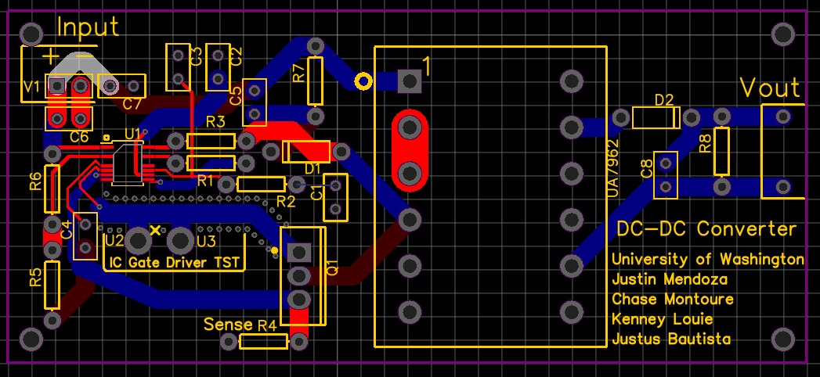

**Comment:** The trace for the gate driver is surrounded by vias. This was due in order to provide isolation to avoid signal crosstalk or other possibility of signal interference. It is critical for the gate driver signal maintains its integrity in order to produce proper output voltage ratio.

**Figure 3.8 - 3D Render of Converter PCB**

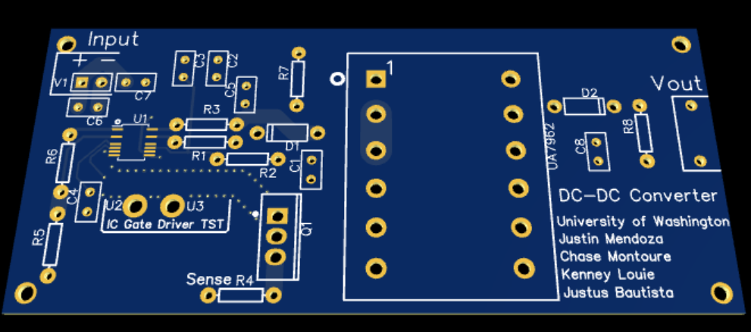

**Figure 3.9 DC-AC Inverter PCB Layout**

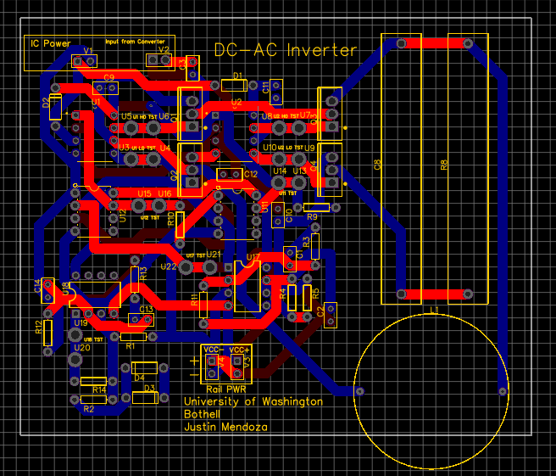

**Comment:** This PCB layout contains 4 layers. In order from top to bottom, is the upper layer (signal), inner layer #1 (signal), inner ground layer (plane), and the bottom layer (signal). Along with a ground copper plane, ground traces can also be found. Test points and labels are also present for easier troubleshooting.

**Figure 3.10 DC-AC Inverter 3D Render**

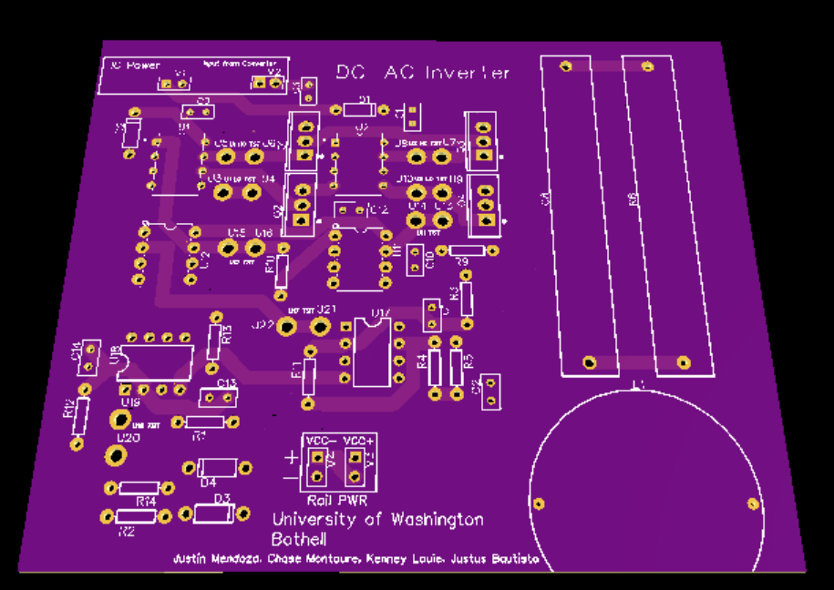

## 4. Test Plan and Results

##### 4.1. Test Plan

##### Test 1: PCB continuity test

Once we have the PCB designed and manufactured we will need to test its continuity by making sure every connection is intact. We will conduct a shorts and opens tests on the PCB using the digital multimeter.

Shorts test: “Check to make sure that NO current flows between separate nets by measuring the amount of resistance between them.”

Opens test: “Check to make sure there is current flow from one "node" to the next for every net on the board, again by measuring the amount of resistance of the conductor.”

Test 2: Converters functionality test

Once we have designed and assembled our two converters we will need to test them to ensure that they work as specified. In order to test them we will be measuring and capturing screen shots of output voltages and waveforms of each converter using the oscilloscope. We will start by checking that the Flyback converter can step up and regulate the output voltage to 24 Vdc. Then we will test the DC-AC inverter by looking at its output voltage and make sure that it meets our specification requirements of X Vrms at 60 Hz.

DC-AC Inverter:

We will begin by verifying that the sine and triangle waveforms are working as expected by comparing the output to our prototype results. Next we will repeat the process with the comparators to verify the PWM control signal. Then finally, we will verify the Full-bridge configuration outputs a sine waveform.

Test 3: Integrated functional test

Once we have both circuits in hand we will need to evaluate the functionality of the system when the Flyback converter and the DC-AC inverter are integrated together. Ensuring that the Flyback converter can provide the appropriate amount of voltage. As well as testing that the inverter can take this input dc voltage and output a sine wave at 60Hz

##### 4.2. Test Results

##### 4.2.1 Prototype hardware test results

PWM control signal

When configuring the sine and triangle wave for our PWM control signal we ran into the issue of having a dc offset on each waveform. This dc offset made it so the waveforms were not symmetrical which resulted in an incorrect PWM control signal. In order to remove this dc offset we placed high pass filters at the output of the sine and triangle wave generators.

**PCB:**

DC-AC Inverter:

Missing 2.446KΩ Connection between pin 6 and 7 found on U17 (NE5532 for triangle wave generator), the solution for this was to short the resistor directly between 6 and 7 and to cut the trace between them.

Missing connection between pin 1 and Diode Biasing junction (D4 and D3) found on U18 (NE5532 for Sine wave generator). The solution was to short the end of diode junction that was not connected to pin 1 directly to the end of R14 that was connected to pin 1.

Incorrect connection at load filter, i.e capacitor is connected to Q_3_3 and Q_4_2. The solution was to cut connection to Q_3_3 and short wire from Q_3_3 to Q_4_2.

Incorrect pin out for sine wave generator, pins 2 and 3 of U18 needed to be switched. The solution was to disconnect the pins and short pin 2 on the opamp to pin 3 in the PCB and repeated the same process for pin 3.

Incorrect connection between C3 and R4.The solution was to cut the trace between them.

Missing connection between pin 6 of U17 and C2. The solution was to short them together.

Wrong comparator was used in PCB schematic (LM311N/NOPB vs LM311P). The solution was to pull pin 1 and 7 out and short output from pin 1 (emitter out) to pin 7 output whole with wire.

DC offset from the sine and triangle wave was present at the output. Solution was to use a high pass filter to eliminate dc offset from the output. Note that two traces (top and bottom layer) had to be cut to add the triangle wave filter and wires were used to add a filter for the sine wave since the output was connected to the comparators within the inner layer of the PCB. Also note that the unfiltered output of both systems must remain connected as intended in the PCB layout since there are feedback loops in each circuit.

DC-DC Flyback Converter:

Incorrect connection of capacitor C3. The solution is connecting C3 between pin 11 on LT3748 and ground.

Pin 8 on LT3748 was not grounded the solution was to ground Pin 8.

Pin 8 and pin 11 on transformer are connected incorrectly. The solution was to connect the diode between pin 8 and ground then short the pins of the diode placeholder to each other.

**Figure 4.1 PWM prototype circuit**

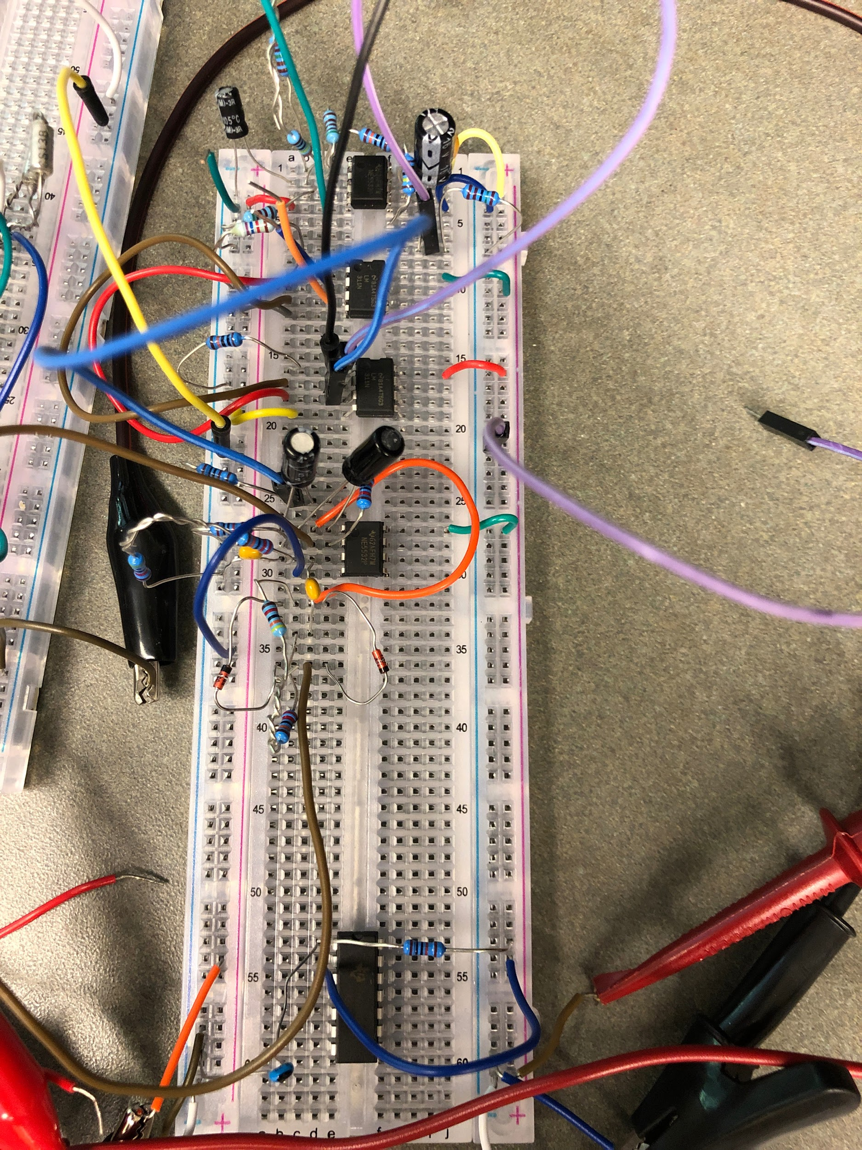

**Figure 4.2 PWM input sine wave**

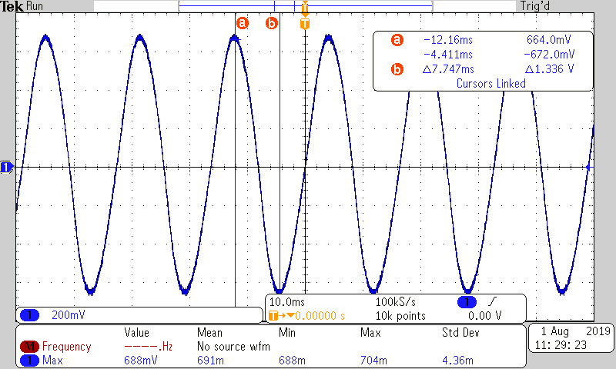

**Figure 4.3 PWM input triangle wave**

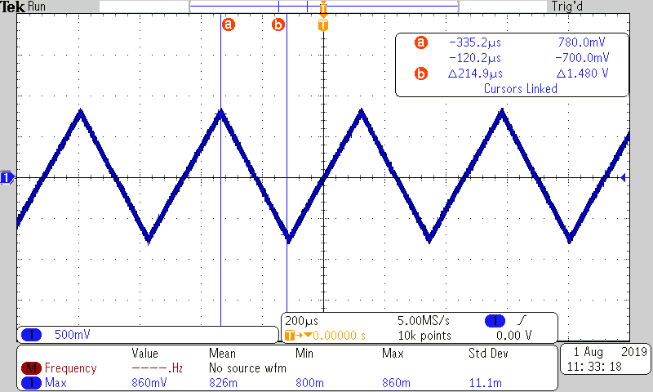

**Figure 4.4 PWM output pulses**

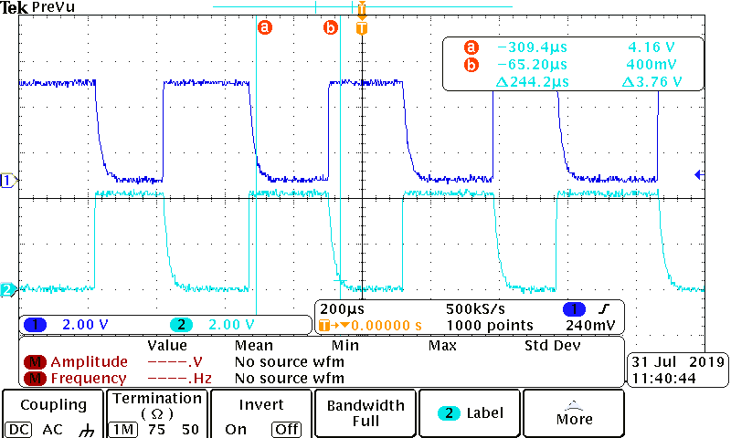

**Comment:** As expected the PWM output from the comparators is complimentary.

DC-AC Inverter

In the beginning of our prototype testing we tried to use a LT1162 Power Mosfet driver to control our pwm input for the full bridge inverter. After a couple weeks of testing we found that this part was to complex for our design and did not have enough time to understand every aspect of the IC in order to have it functioning correctly. As a result of this we decided to move on from this IC and began testing again with the IR2304 Power Mosfet driver.

**Figure 4.5 DC-AC inverter prototype top view**

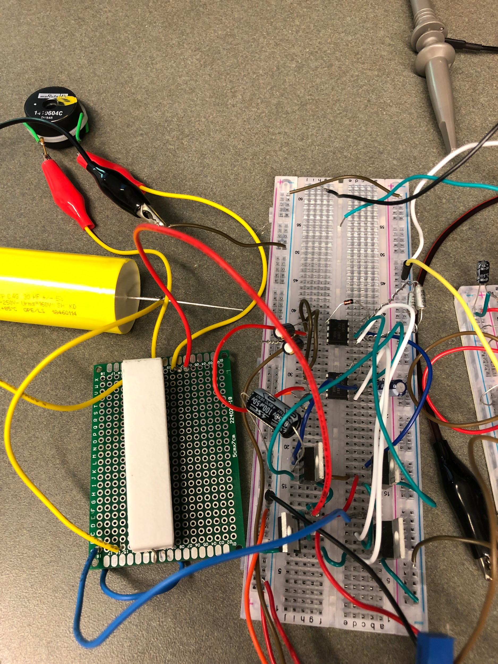

**Figure 4.6 DC-DC Flyback converter prototyper top view**

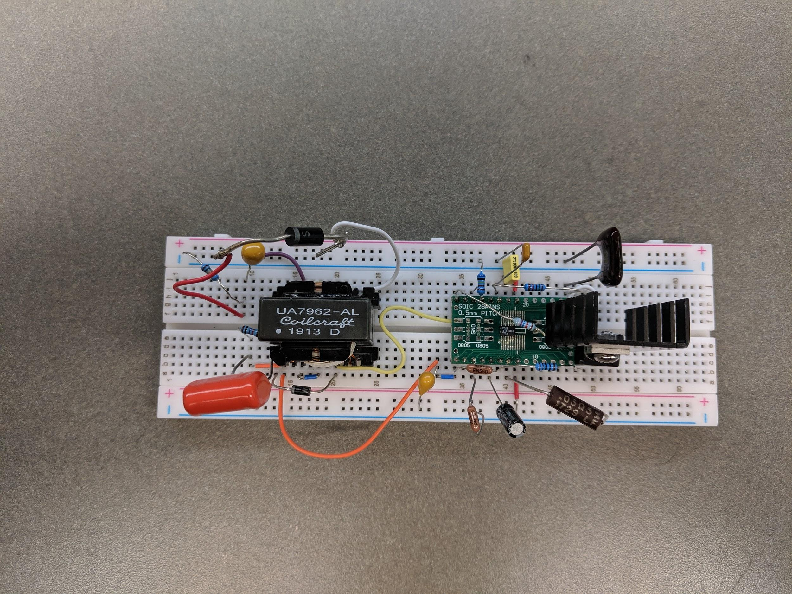

##### 4.2.2 PCB test results

**Figure 4.7 DC-AC Inverter**

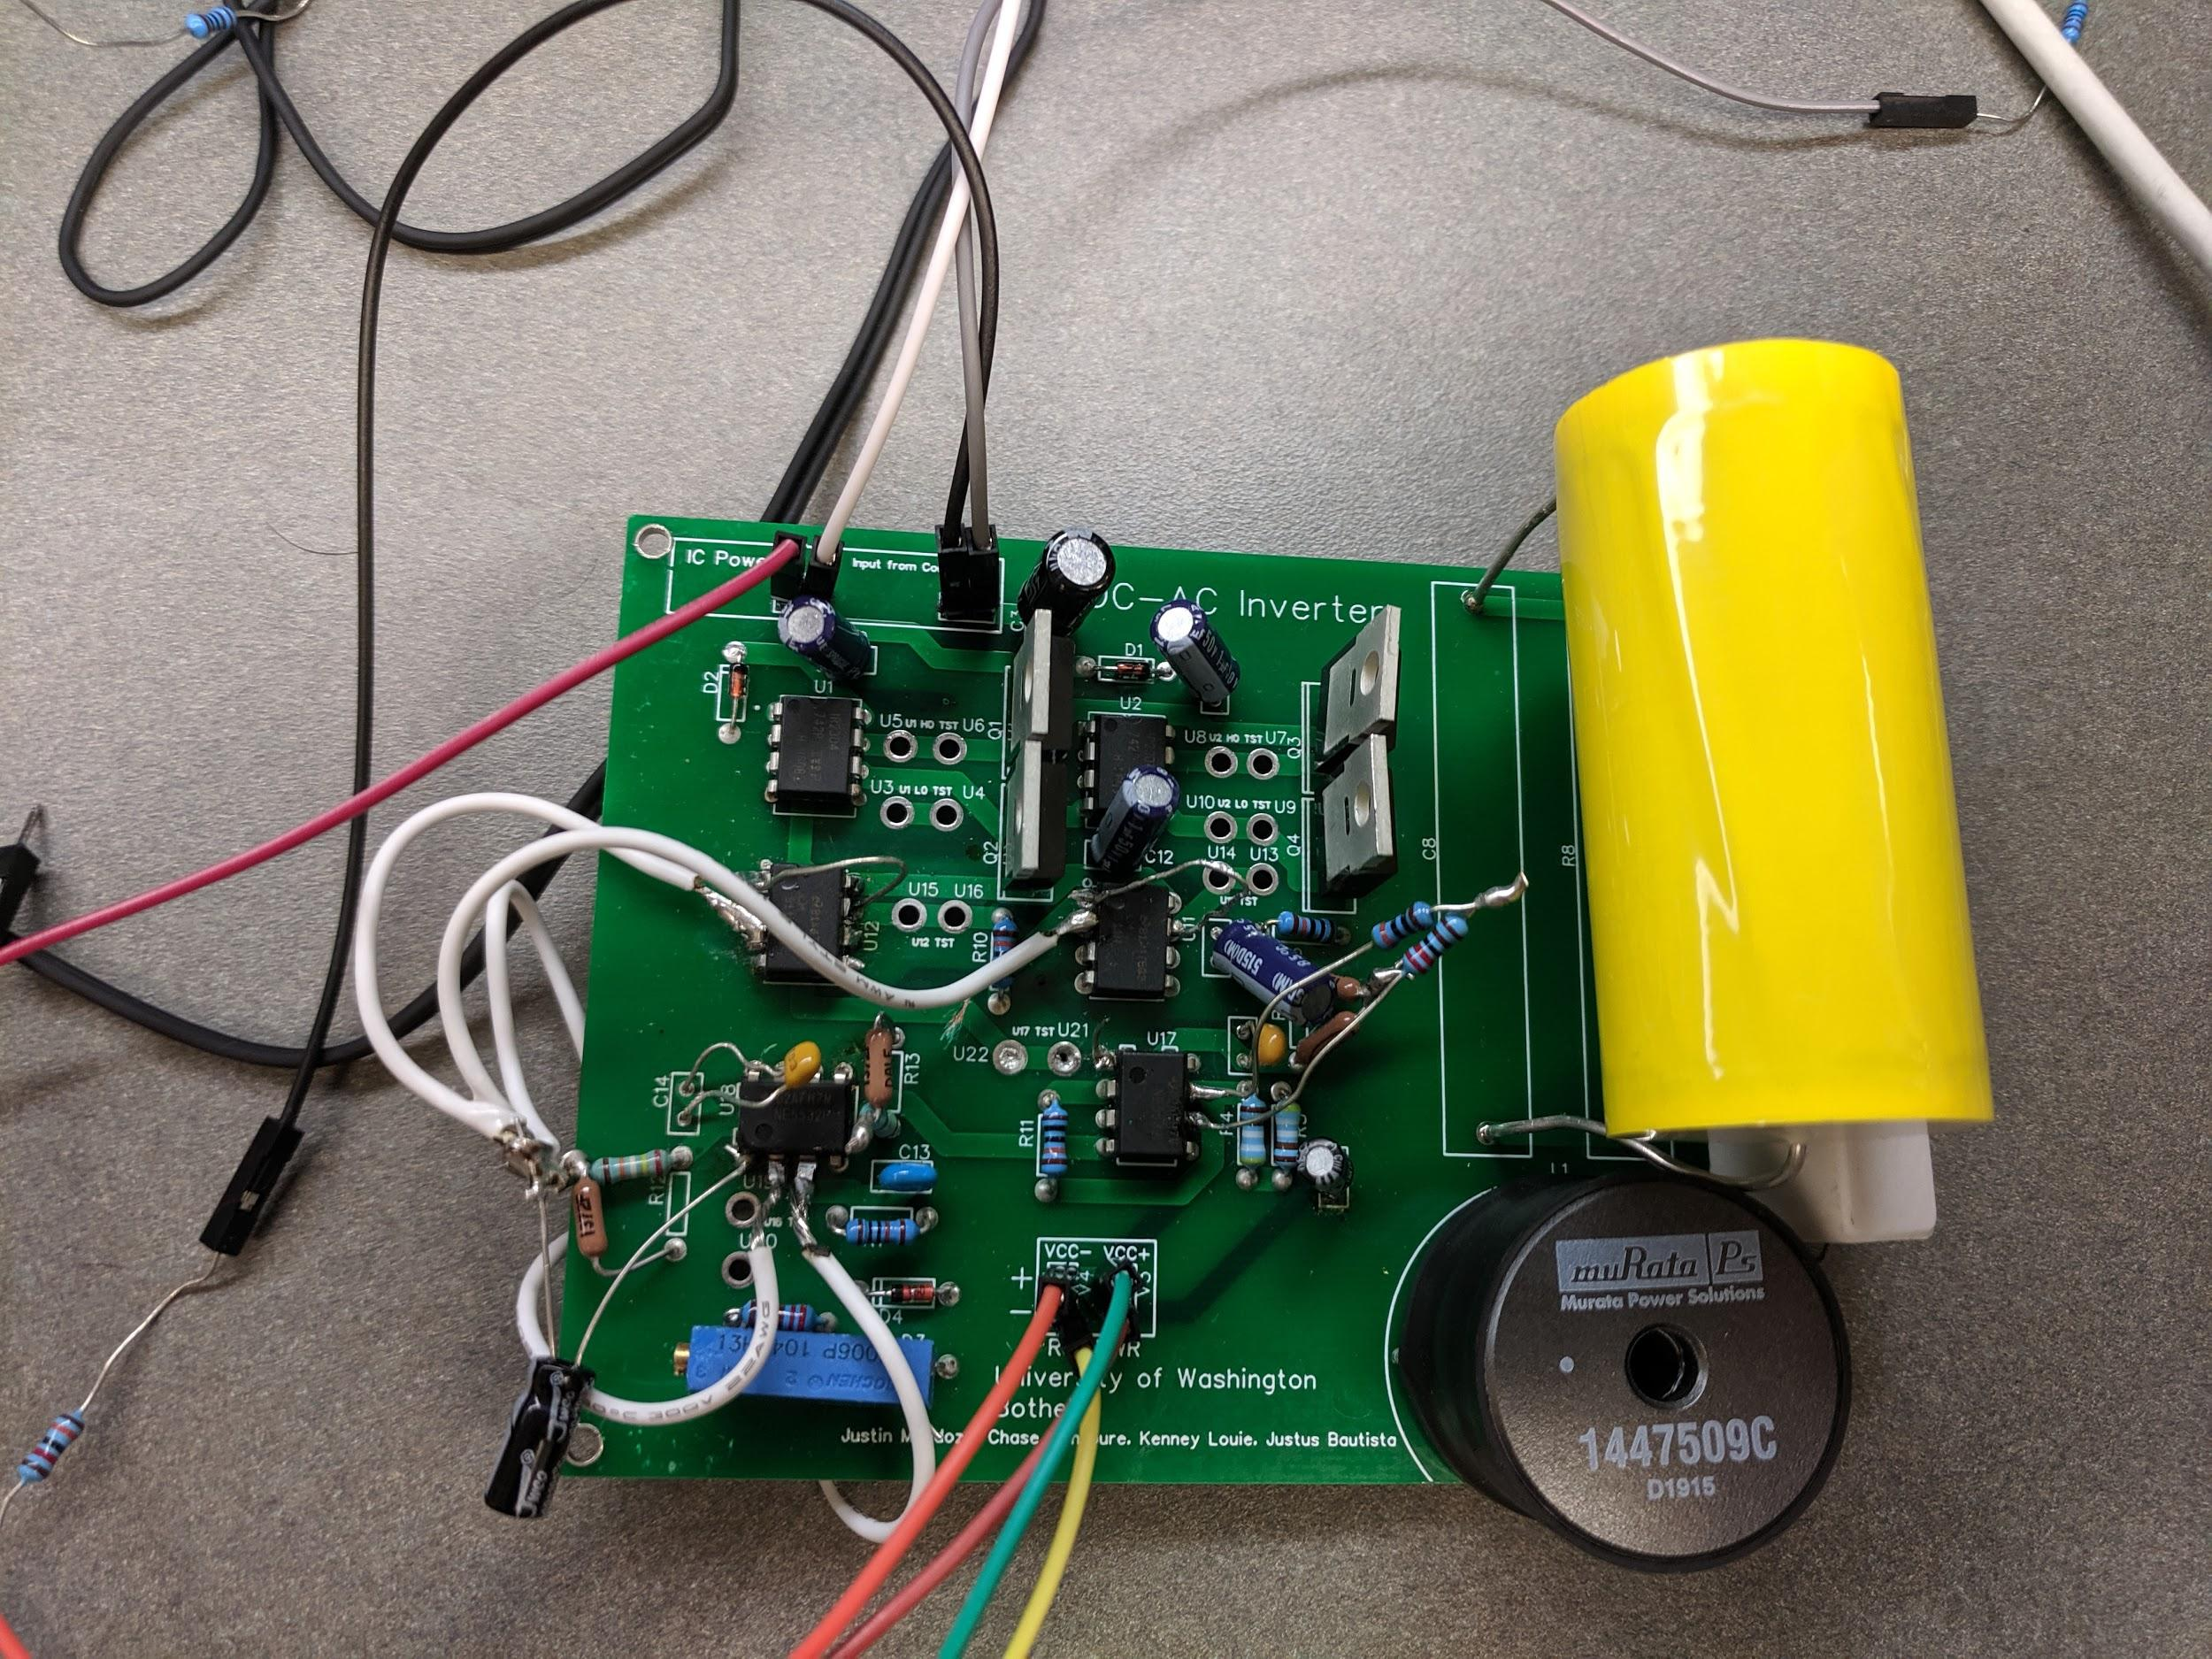

***Control signals***

**Figure 4.8 Sine Wave**

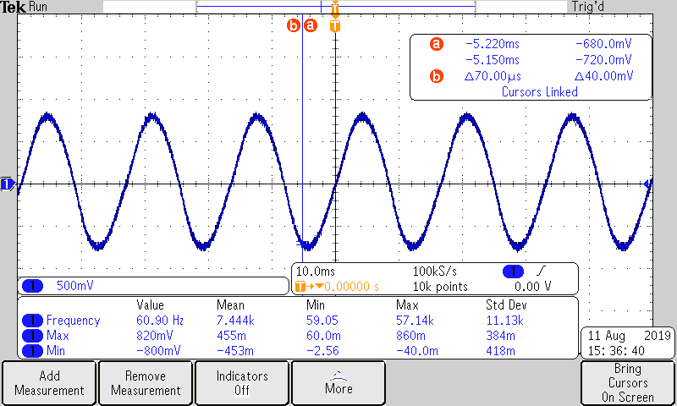

**Figure 4.9 Triangle wave**

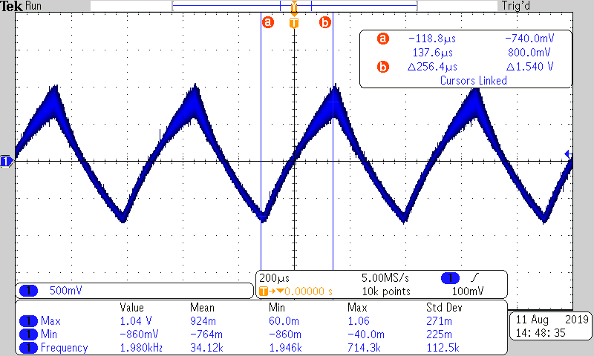

**Figure 4.10 PWM output**

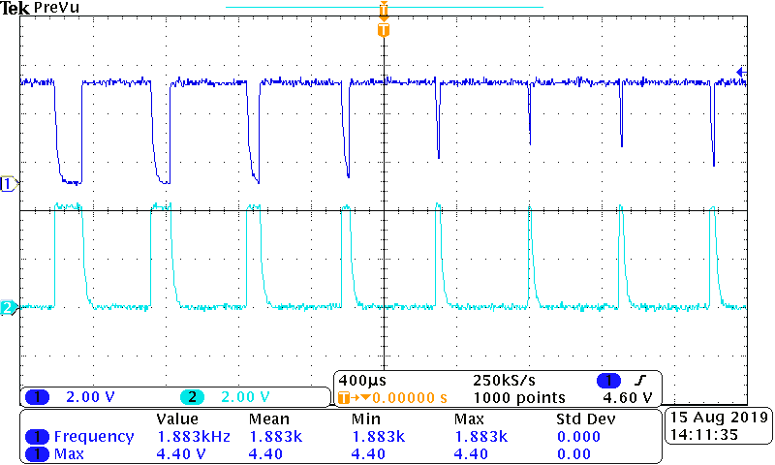

**Figure 4.11 Sine wave output (Full-bridge) at 25V input**

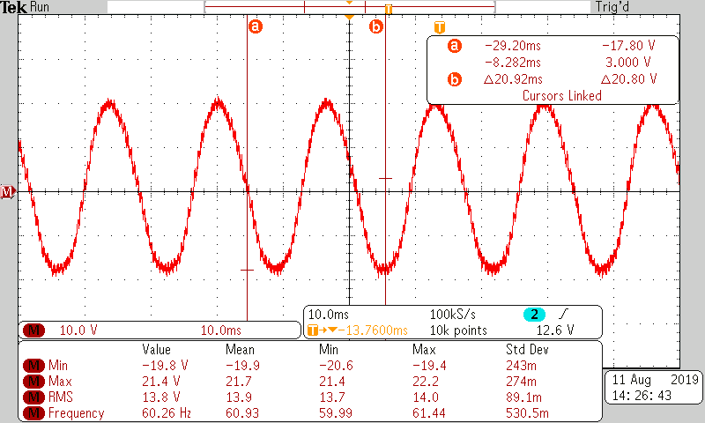

**Note:** The High pass filter error was discovered after the PCB was ordered therefore modification had to be made to the PCB in order to add the additional filtering.

**Flyback Converter**

**Figure 4.12 Gate Voltage from LT3748**

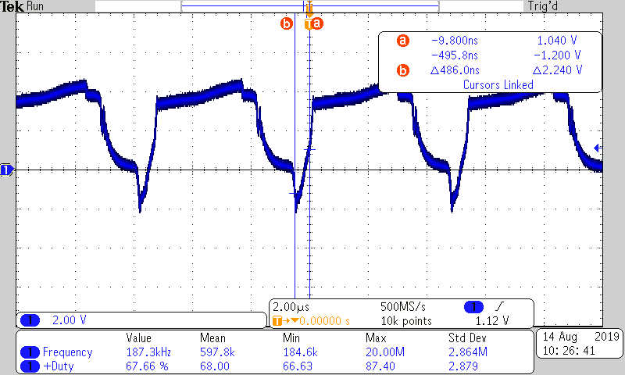

**Figure 4.13 Output Voltage from Flyback Converter**

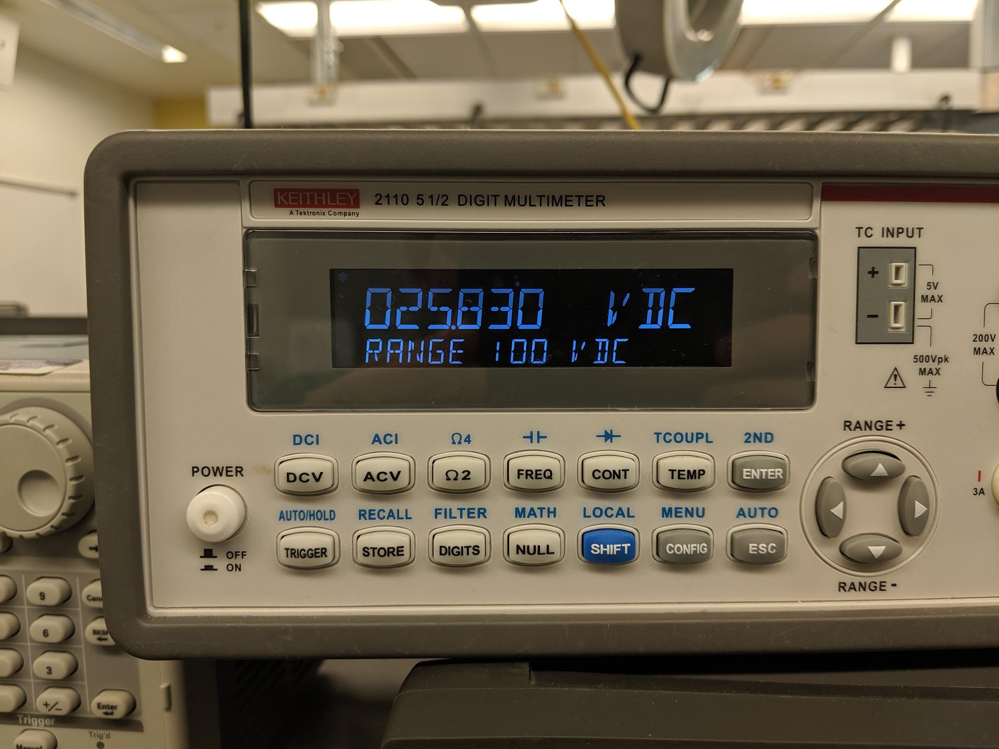

**5. Schedule and Milestones**

**Table 5.1 Tentative Schedule of Capstone 1**

|  |  |  |
| --- | --- | --- |
| Tasks | Start Date | End Date |
| Capstone 1 |  |  |
| Contract | 4/1/2019 | 5/15/2019 |
| Preliminary Design (High-Level) | 5/15/2019 | 5/22/2019 |
| Test/Validation Plan | 5/22/2019 | 5/29/2019 |
| Converter Architecture/Simulations | 5/15/2019 | 5/22/2019 |
| Preliminary Bill of Parts | 5/22/2019 | 5/27/2019 |
| Proposal | 5/15/2019 | 6/5/2019 |

**Table 5.2 Tentative Schedule of Capstone 2**

|  |  |  |
| --- | --- | --- |
| Capstone 2 |  |  |
| Finalize Circuit Design | 6/17/2019 | 6/21/2019 |
| Finalize Bill of Parts | 6/22/2019 | 6/24/2019 |
| Purchase of Parts | 6/24/2019 | 7/7/2019 |
| PCB Design (Layout) | 6/22/2019 | 7/24/2019 |
| PCB Order | 7/24/2019 | 8/2/2019 |
| PCB Assembly | 8/2/2019 | 8/4/2019 |
| PCB Test | 8/4/2019 | 8/6/2019 |
| Lab Test | 8/6/2019 | 8/11/2019 |
| Troubleshoot | 8/11/2019 | 8/18/2019 |
| Final Report | 7/23/2019 | 8/18/2019 |
| Presentation | 8/12/2019 | 8/22/2019 |

## 6. Reflections

##### 6.1. Accomplishments

Throughout the duration of the project, we have reached important milestones that brought the project to this point. We are proud of our own work and results, and as well accomplish numerous tasks that we learned from and evolved from it.

Selecting Components: In the beginning of our project, our team had high level diagrams of how our circuit will function, but when it came to specifics, our group had numerous possibilities in choosing components. Given the amount of part manufacturers, and how our group will design the circuit topology, at first it was daunting in selecting which parts we will use. The part selecting process was both simple and difficult. For the case of the inverter, the majority of our components met our needs on the first or second interactions of design. In contrast, component selection of the flyback converter was more troubled. Initial selection of parts gave difficulty during testing. As a result,

PCB Design**:** Throughout the duration of our education within the university, the majority of the circuits we tested were built on matrix boards, also known as breadboards. However, in real industry PCBs are used universally for circuits. Our capstone project allowed us to practice our skills in PCB design and order them as tangible feedback on our work.

##### 6.2. Learning Experience

Over the course of the capstone project, one lesson we learned how much time can be an influencer in decision making. Our second phase of our Capstone project was in the Summer quarter, which meant were provided less time to verify our decisions with additional weight of an immovable deadline. Looking back, our group would have prevented more potential issues given more time within the regular academic quarter.

Another lesson we took note is anticipating possible scenarios in which could threaten progress within the project. For example, when it came to ordering parts for prototyping, it was necessary to order a spares or include alternative components to avoid full reliance on a handful of components, all while also trying to manage our limited budget. Our team also brought personal equipment to perform specialized tasks that university equipment were unable to do. Preparations such as these allow us to divert more time in important priorities rather than to waste it due to avoidable mistakes.

##### 6.3. Team Experience

##### 6.4. What Would We Have Done Differently?

We would have used an integrated circuit to generate the sine and triangle wave generators.

In general we would have used our time more efficiently and take more time to inform ourselves about the components that we were purchasing. In particular we would have taken the time to better understand the IC’s we bought to endure they were manageable to work with and troubleshoot.

##### 6.5. Future Work

If a team wishes to continue our project of the solar panel inverter, tasks that we would like to see accomplished include the following.

Single Power supply: In a real system the Inverter would be powered off of battery in the PV system. Future capstone student could implement additional DC-converter circuits for the IC’s in order to run the system off a single power supply.

Improved control system: The PWM system we created was crude and not necessarily the most efficient method of generating the control signal. Future capstone student could improve on our design by implementing the PWM control using a microcontroller or more precise IC’s.

Upscaled Model: Due to the lack of a company sponsor and the available equipment we were unable to implement a full-scale model of the system. Future students with the proper guidance could implement an up-scale or full-scale model. Note that other concerns could come into play such as heat distribution in the system and safety.

## 7. References

*“Advanced Circuits.” PCB Manufacturer - PCB Electrical Testing | Advanced Circuits,* [*www.4pcb.com/pcb-electrical-testing.html.*](http://www.4pcb.com/pcb-electrical-testing.html.)

*“Cyril BUTTAY -- Schematic of a Flyback Converter .” Wikipedia .*

*From Wikimedia Commons, the free media repository*

*“IR2304(S) & (PbF).” International Rectifier .*

*Data Sheet No. PD60200 revB*

*“Pulse Width Modulation.” All About Circuits, 28 June 2018,* [*www.allaboutcircuits.com/textbook/semiconductors/chpt-11/pulse-width-modulation/.*](http://www.allaboutcircuits.com/textbook/semiconductors/chpt-11/pulse-width-modulation/.)

## 8. Acknowledgements

We would like to thank Dr. Harry Aintablian for giving us feedback & guidance as our industrial & academic advisor, Dr. Kyoung Tae Kim & Skyler Klagenburg for helping ordering project components, as well as students Nathan Pham, Mike Miller and Anthony Scharkov for additional advice and components.

## 9. Appendices

##### 9.1 Flyback converter Bill of Materials

|  |  |  |  |  |  |  |
| --- | --- | --- | --- | --- | --- | --- |
| **\*Part** | **Description** | **Pins** | **Quantity** | **Manufacturer** | **Vendor** | **Cost Per Unit** |
| IRF540 | FET | 3 | 1 | Infineon | Mouser | 1.05 |
| LT3748 | IC | 10 | 1 | Linear Technologies | Mouser | 7.55 |
| UA7962-AL | Transformer | 12 | 1 | Coilcraft | Mouser | 10.62 |
| TAP476K035CRW | 47u Cap | N/A | 1 | AVX Corp. | Mouser | 6.00 |
| TAP106M025SCS | 10u Cap | N/A | 1 | AVX Corp. | Mouser | 0.86 |
| TAP106K035CRW | 4.7u Cap | N/A | 1 | AVX Corp. | Mouser | 1.54 |
| NTE577 | 100V Diode | N/A | 2 | NTE Electronics | Mouser | 3.28 |
| CW02B10K00JE12 | 10K Ohm Resistor | N/A | 3 | Vishay/Dale | Mouser | 1.23 |
| LOB3R030JLF | 30m Ohm Current Sense Resistor | N/A | 1 | Welwyn Components / TT Electronics | Mouser | 0.86 |
| CMF506K0400FHEB | 6.04k Ohm Resistor | N/A | 1 | Vishay/Dale | Mouser | 0.67 |
| CW010100K0JE12 | 100k Ohm Resistor | N/A | 1 | Vishay/Dale | Mouser | 3.08 |
| CMF5520K400BEEK | 20.4k Ohm Resistor | N/A | 1 | Vishay/Dale | Mouser | 1.26 |
| SA102A101JARN | 100p Cap | N/A | 1 | AVX Corp. | Mouser | 0.21 |
| RDER71H222K0M1H03A | 2.2n Cap | N/A | 1 | w | Mouser | 0.42 |
| C430C104M1U5TA | .1u Cap | N/A | 1 | KEMET | Mouser | 0.41 |
| MKT1813422255 | .22u Cap | N/A | 1 | Vishay / Roederstein | Mouser | 1.19 |

##### 9.2 Dc to AC inverter Bill of Materials

|  |  |  |  |  |  |  |
| --- | --- | --- | --- | --- | --- | --- |
| **\*Part** | **Description** | **Pins** | **Quantity** | **Manufacturer** | **Vendor** | **Cost Per Unit** |
| ***PWM Controller*** | | | | | | |
| LM311NP | Differential Comparator | 8 | 2 | Texas Instruments | **Digi-Key | 0.11625 |
| NE5532 | High Performance Op-Amp  (Dual) | 8 | 2 | Texas Instruments | **Digi-Key | .85 |
| Resistors (various) | ¼ W through hole resistors | N/A | 12 | Misc. | **Digi-Key | <.1 |
| 3006P-104LF-ND | ¾ W 100K potiometer | 3 | 1 | Bourns Inc | **Digi-Key | $2.08 |
| ***PWM Controller / Full-Bridge Inverter*** | | | | | | |
| electrolytic Capacitors (various) | Low Voltage Capacitors (polarized) | N/A | ***1-11 | Misc. | **Digi-key | .10 |
| 1N4148 | General purpose diode | N/A | 4 | On semiconductor | **Digi-key | .10 |
| Ceramic Capacitors | Low Voltage Capacitors (non-polarized) | N/A | ***1-11 | MIsc. | **Digi-key | .10 |
| ***Full-Bridge Inverter*** | | | | | | |
| IRFB31N20DPBF | 200V 31A MOSFET | 3 | 4 | International Rectifier | Mouser | $2.08 |
| NTE-25W39omh | 25W 39 ohm Power resistor | N/A | 1 | NTE | Vetco | 1.73 |
| IR2304 | Half-bridge  MOSFET Driver 600V | 8 | 2 | International Rectifier | Mouser | 1.95 |
| 1447509C | 4.7mH .9A inductor | 2 | 1 | Murata Power Solutions | Mouser | 4.04 |
| C4GADUD5300AA3J | 30uF 250V Film Capacitor | N/A | 1 | Kemet | Mouser | 8.19 |
| **Total** | $32.86 | | | | | |

*All parts listed are through hole mounting type

**parts were found in the University of Washington Bothell electrical engineering (EE) labs but are available at vendors

***quantity dependent on available capacitor values and types found in EE lab